Algebra 3-4 Name

Block Date

**Unit 1: Equations, Inequalities, Functions and Graphs**

**Level 2**

**Solve the equation.**

1. 1.)  2.) ** 3.) **

*1.) ___________________ 2.) ___________________ 3.) ___________________*

**Solve the equation for the indicated variable.**

4.) , for *t* 5.) , for *U*

*4.) ___________________ 5.) ___________________*

**Solve the inequality. Graph the solution set on a number line below.**

6. ) 8  2 + 2*k* 7.) 9 – 2r   5

|  |
| --- |
|  |
|  |
|  |

**Solve the absolute value equation.**

8.)  9.) 

*8.) ___________________ 9.) ___________________*

**10. Find the domain and range of the relation, then determine whether it is a function.**

$\left\{\left(2, 1\right), \left(-4, 5\right), \left(1, 7\right), \left(2, -3\right), \left(-1, 2\right)\right\}$

**Domain:**

**Range:**

**Function?**

**Level 3**

**Are the following *always*, *sometimes*, or *never* true? Show your work.**

1) 

|  |  |  |  |  |  |
| --- | --- | --- | --- | --- | --- |
| a. | always | b. | sometimes | c. | never |

**Solve the equation.**

2.)  `

*2.) ___________________*

**Solve the compound inequality. Graph the solution on the number line below.**

3.) 4*x* + 3  –17 and 7*x* – 4  10 4.) 9*x* – 5 < –41 or 3*x* + 13 > 7

|  |  |  |  |
| --- | --- | --- | --- |
|  |  |  |  |
|  |  |  |  |

|  |  |  |  |
| --- | --- | --- | --- |
|  |  |  |  |
|  |  |  |  |

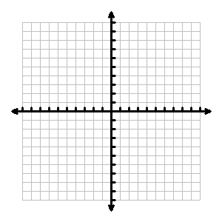

5.) Graph: $y=-2x+8$

**Write the equation of the line with the given characteristics.**

6.)through $\left(1, 5\right) and \left(-3, 3\right)$ 7.)Parallel to $y=2x-5$ and through $\left(4, 1\right)$

*6.) ___________________ 7.) ___________________*

**8. How far apart are the points (4, -7) and (-2, 5) ?**

*8.) ___________________*

|  |  |  |
| --- | --- | --- |
|  |  |  |

**Level 4**

**Use an algebraic equation to solve the problem.**

1.) Two cars leave Denver at the same time and travel in opposite directions. One car travels 10 mi/h faster than the other car. The cars are 300 mi apart in 3 h. **Write an equation and solve to find out how fast each car is traveling.**

|  |  |  |  |
| --- | --- | --- | --- |
|  |  |  |  |
|  |  |  |  |
|  |  |  |  |
|  |  |  |  |

|  |  |  |  |
| --- | --- | --- | --- |
|  |  |  |  |

1. **­­­­­­­­­­_______________________________**